**Cosmetics Sales Analytics Project**

**Sales Performance and Forecasting Dashboard for a Retail Store---Cosmetics_Sales_Analytics_Project.xlsx(dataset)**

Total Revenue, Quantity Sold, Total Orders

SELECT

COUNT(DISTINCT ORDER_ID) AS TOTAL_ORDERS,

SUM(QUANTITY) AS TOTAL_QUANTITY,

SUM(REVENUE) AS TOTAL_REVENUE

FROM SALES_DATA_COSMETICS;

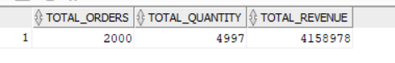

Monthly Sales Trend

SELECT

TO_CHAR(ORDER_DATE,'YYYY-MM') AS MONTH,

SUM(REVENUE) AS MONTHLY_REVENUE

FROM SALES_DATA_COSMETICS

GROUP BY TO_CHAR(ORDER_DATE,'YYYY-MM')

ORDER BY MONTH;

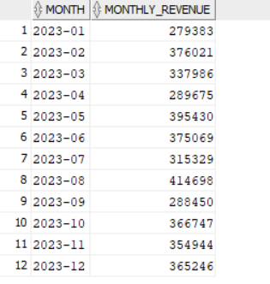

Revenue by Product Category

SELECT

PRODUCT_CATEGORY,

SUM(REVENUE) AS TOTAL_REVENUE

FROM SALES_DATA_COSMETICS

GROUP BY PRODUCT_CATEGORY

ORDER BY TOTAL_REVENUE DESC;

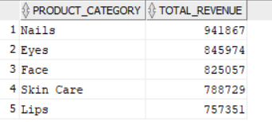

Top 5 Products by Revenue

SELECT * FROM (

SELECT Product_Name,

SUM(Revenue) AS Total_Revenue

FROM SALES_DATA_COSMETICS

GROUP BY Product_Name

ORDER BY Total_Revenue DESC

) WHERE ROWNUM <=5;

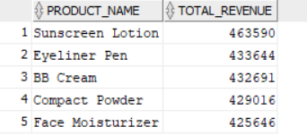

Least 5 products by Revenue

SELECT * FROM (

SELECT product_name,

SUM(Revenue) AS Total_Revenue

FROM SALES_DATA_COSMETICS

GROUP BY product_name

ORDER BY Total_Revenue ASC

) WHERE ROWNUM<=5

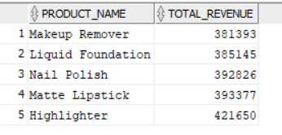

**Revenue by Region**

SELECT

REGION,

SUM(REVENUE) AS TOTAL_REVENUE

FROM SALES_DATA_COSMETICS

GROUP BY REGION

ORDER BY TOTAL_REVENUE DESC;

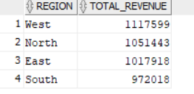

Sales by Payment Method

SELECT

PAYMENT_METHOD,

SUM(REVENUE) AS TOTAL_REVENUE

FROM SALES_DATA_COSMETICS

GROUP BY PAYMENT_METHOD

ORDER BY TOTAL_REVENUE DESC;

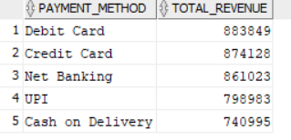

Customer Demographics: Gender-wise Revenue

SELECT

CUSTOMER_GENDER,

COUNT(DISTINCT CUSTOMER_ID) AS CUSTOMERS,

SUM(REVENUE) AS TOTAL_REVENUE

FROM SALES_DATA_COSMETICS

GROUP BY CUSTOMER_GENDER;

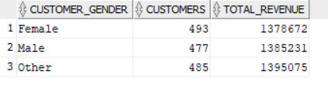

Orders with Returns

SELECT

COUNT(*) AS Returned_Orders,

SUM(Revenue) AS Returned_Revenue

FROM SALES_DATA_COSMETICS

WHERE Return_Flag = 1;

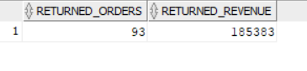

Delivery Status Analysis

SELECT

Delivery_Status,

COUNT(*) AS Order_Count,

SUM(Revenue) AS Revenue

FROM SALES_DATA_COSMETICS

GROUP BY Delivery_Status;

